

**FPT International School**

--- o0o ---

**PROJECT REPORT**

**Gracious Garment**

Batch: T1904a

Semester: 1

Group: Positivity

1. TH1902012 Dao Ngoc Long
2. TH1904011 Dinh Vu
3. TH1903002 Ngo Van Duy
4. TH1904003 Ho Ly Thai
5. TH1903012 Tran Hung Son

HaNoi,2019

Table of Contents

**1.** **Problem Definition** 4

**1.1** **Overview** 4

**1.1.1** **Introduction:** 4

**1.1.2** **Implementation Environment** 4

**1.2** **User stories** 5

**1.2.1** **First impression: Home page** 5

**1.2.2** **Placing order experience: Product. Product Detail.** 5

**1.2.3** **Find a product. Compare products.** 5

**1.2.4** **Other pages: About us, Contact us, FAQ, Contact us.** 5

**2. Database**: 6

**2.1** **Table Order** 6

**2.2** **Table Product** 6

**3.** **UI/UX:** 6

**4.** **Summary:** 6

# 

1. **Problem Definition**
   1. **Overview**
      1. **Introduction:**

**Requirement Specification:**

The Web site is to be created based on the following requirements.

1. The Home Page should be created making use of Frames with a suitable logo.
2. Home Page should contain details of different Garments with suitable images.
3. The site should display a menu which will contain the options for brief introduction about the various garments available, location of the shop and any other information if required.
4. The information should be categorized according to the brand names of the products like if a User wants to see only “Van Heusen” products or any other companies products then he/she can click on a Link/button/menu etc and can see only that Brand products.
5. When a user selects any particular brand, a list of products for that brand will be displayed
6. A brief summary of features of individual products should be displayed on the Web Page along with the product but detailed Features should be stored in Individual Word documents which can be downloaded or viewed by the User who wishes to see the same.
7. The user should also be able to compare the various products of different as well as similar brands.­
8. There should be a “Contact Us” page which will have the Address of the Company which is as follows and the mail address which when clicked will invoke the local mail client from where they can send an email. Address of the Company should be displayed using GeoLocation API (eg. GoogleMaps).
   * 1. **Implementation Environment**

* Platform
* Windows 10
* Language
* HTML 5
* CSS3
* Javascript
* JQuery
* Bootstrap 3
* Application
* JetBrains Webstorm
* Chrome
* FireFox
  1. **User stories**
     1. **First impression: Home page**

As an normal customer who is distracted by many online contents and online ads everyday, I want the Home Page of my favorite clothes store to be full of unique and beautiful designs, new trends and famous brands.

* + 1. **Placing order experience: Product. Product Detail.**

Nowadays, no one has more than 15 minutes to find out how a website works. The complexity of navigation or site structure will decrease interest of customers. They rather hit “close tab” and look for other alternatives that are always there to fill their need. Thanks to the conventional design of Gracious Garment, I can easily stroll through out the website without any problem. Viewing products, choosing them and placing orders feel like a flow experience.

* + 1. **Find a product. Compare products.**

Since GRACIOUS GARMENTS is selling various types of garments of many brands for both men and women, they have quite a lot products in many different brands. Finding and comparing products could be tricky if they place the whole list of more than 50 products in one page. Having this in mind, the web designer has group products by brands and a detailed filter. So whatever I want, I can easily find it.

* + 1. **Other pages: About us, Contact us, FAQ, Contact us.**

Last but not least, a website can’t be a real website if it contains only homepage and product page. Other pages like About Us, Contact Us… should be there as well in case I want to look for information or contact with the company to send feedback about their products or even ask them for a business contract based on franchising principles.

# Database:

* 1. **Table Order**

|  |  |  |
| --- | --- | --- |
| **Column Name** | **Data Type** | **Description** |
| billingName | String | Customer name on billing info |
| billingAddress | String | Customer address on billing info |
| billingPhone | String | Customer phone on billing info |
| deliveryName | String | Customer name on delivery info |
| deliveryAddress | String | Customer address on delivery info |
| deliveryPhone | String | Customer phone on delivery info |
| product | Array | List of products ordered by user stored in an array |
| payment | String | Type of payment |
| shipping | String | Type of shipping |
| totalPrice | Number | Total price for easier tracking |
| comment | String | User comment |

* 1. **Table Product**

|  |  |  |
| --- | --- | --- |
| **Column Name** | **Data Type** | **Description** |
| productName | String | Product’s name |
| productPermalink | String | Product’s permalink |
| productPrice | Number | Product’s price |
| productCategory | String | Product’s category |
| productColor | String | Product’s color |
| productBrand | String | Product’s brand |
| productBrandPermalink | String | Product’s brand permalink |
| productSize | String | Product’s size |
| productImg | String | Product’s image url |
| productDoc | String | Product’s word file url |
| productDesc | String | Product’s description |

1. **UI/UX:**

**Homepage:**

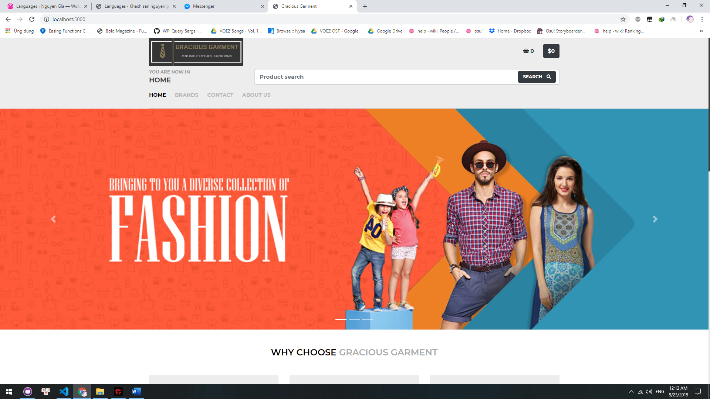

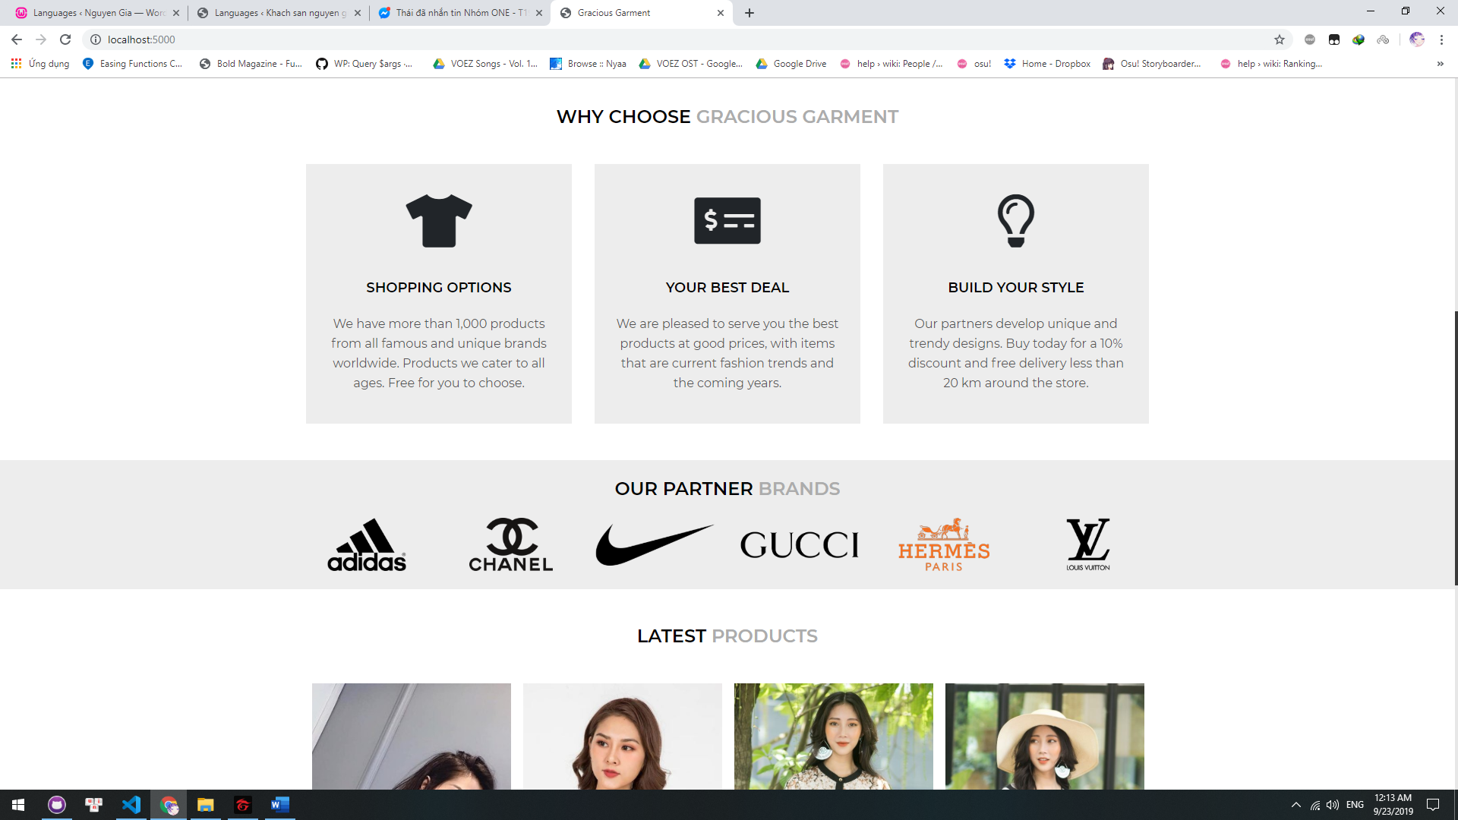

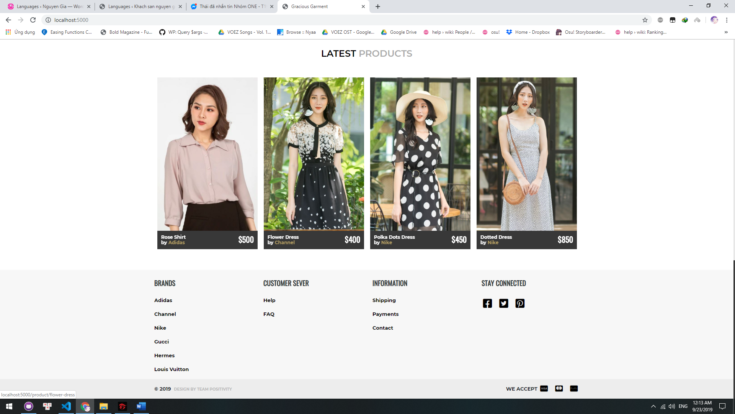

**All brands/ specific brand page:**

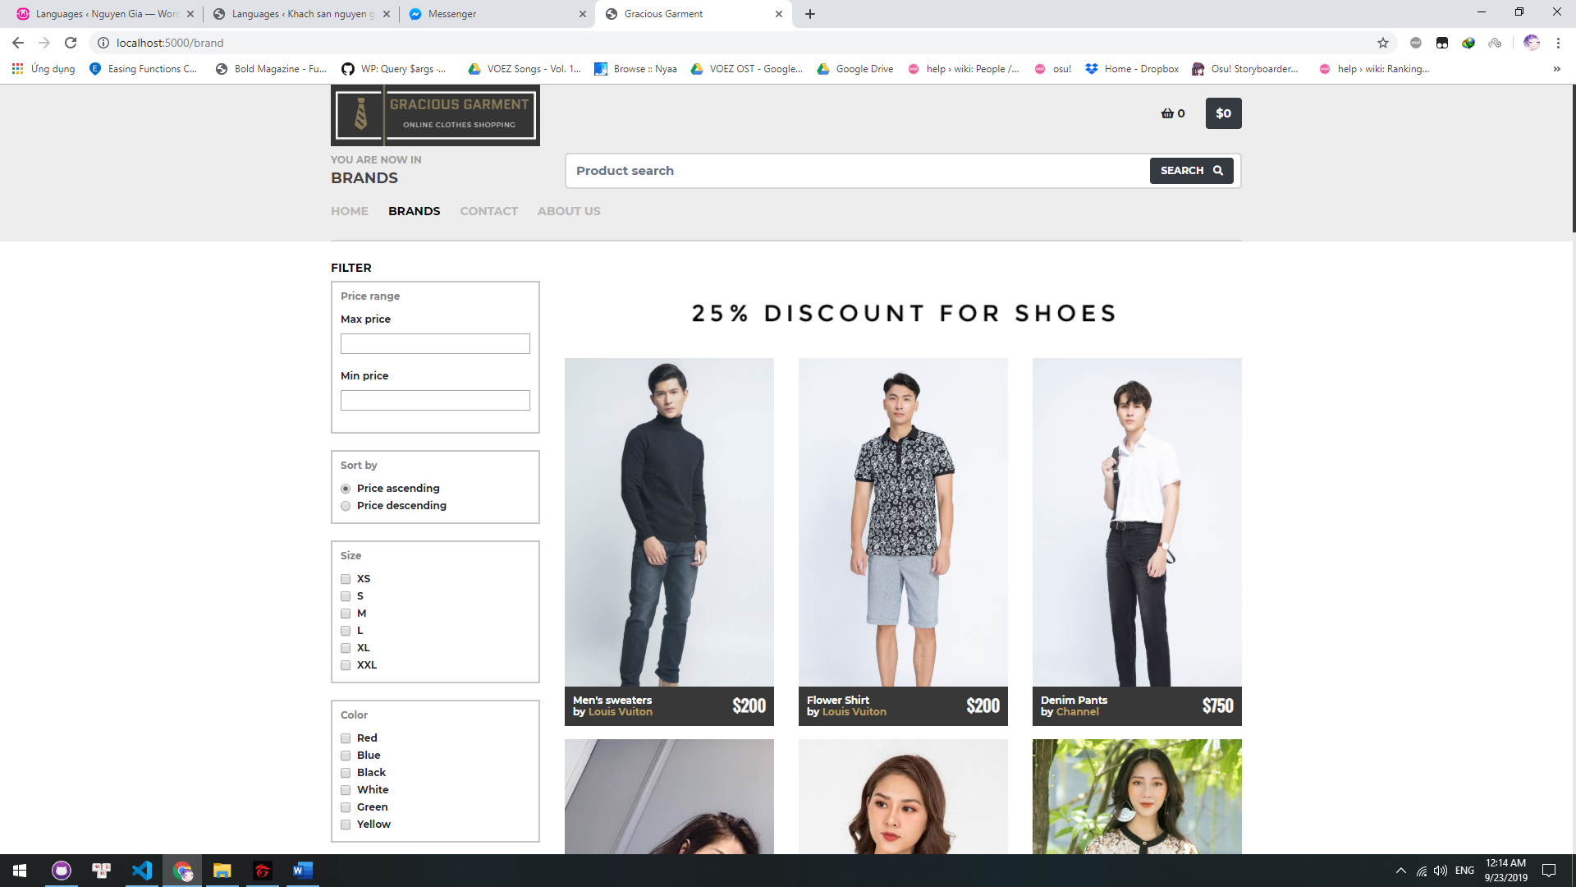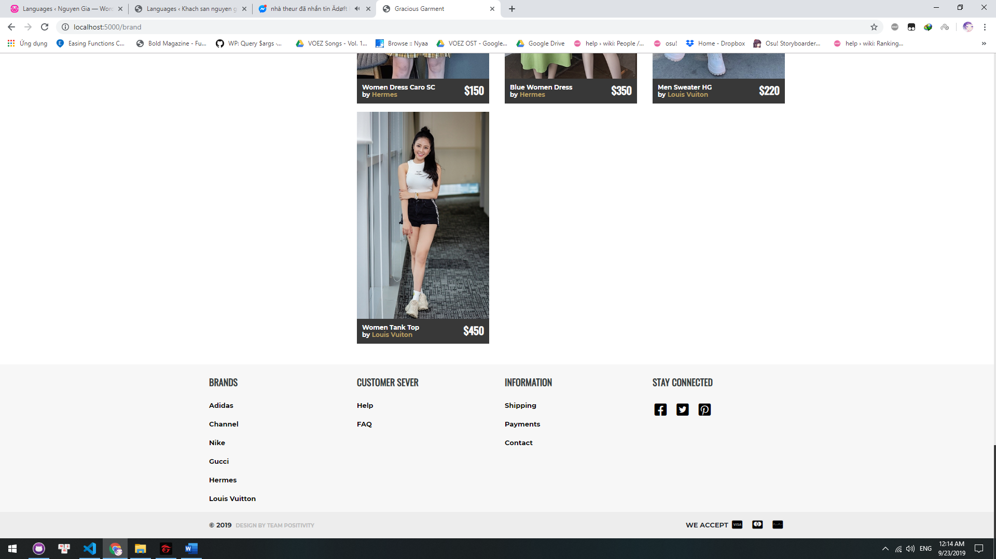

**Product detail:**

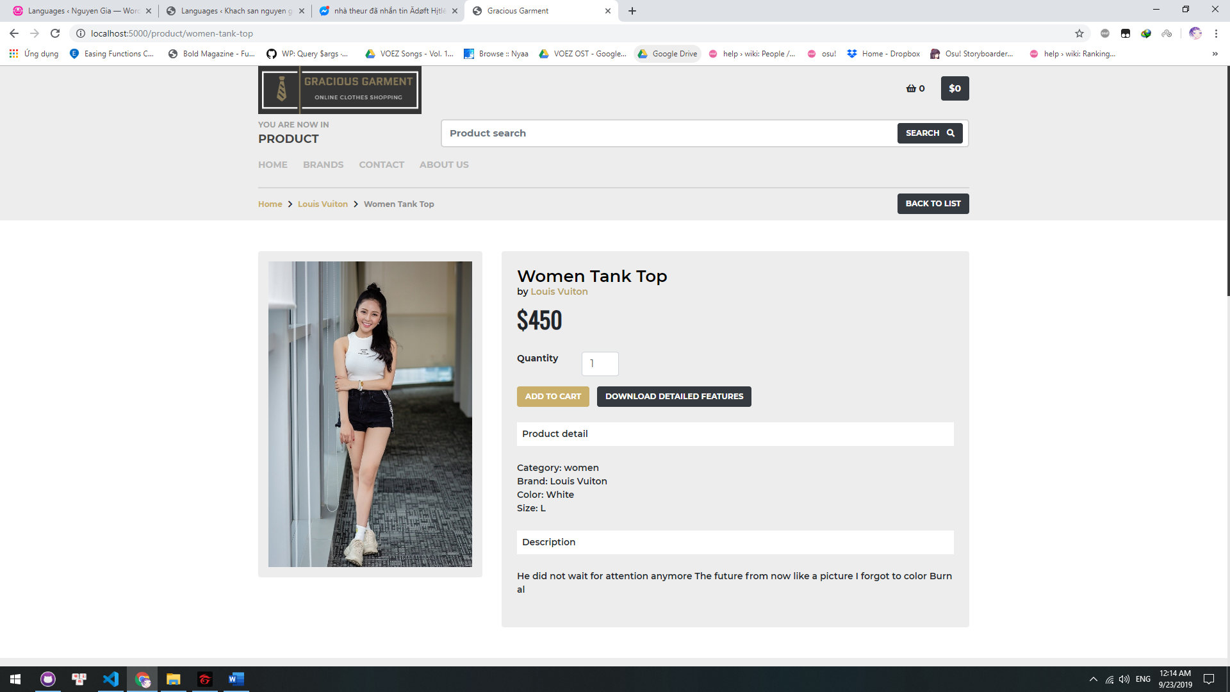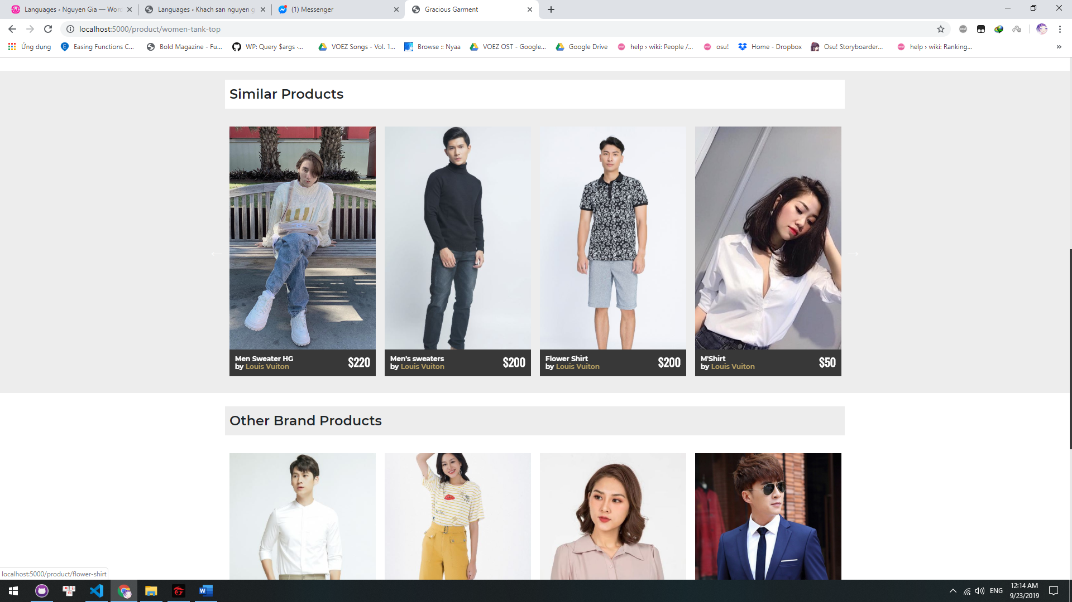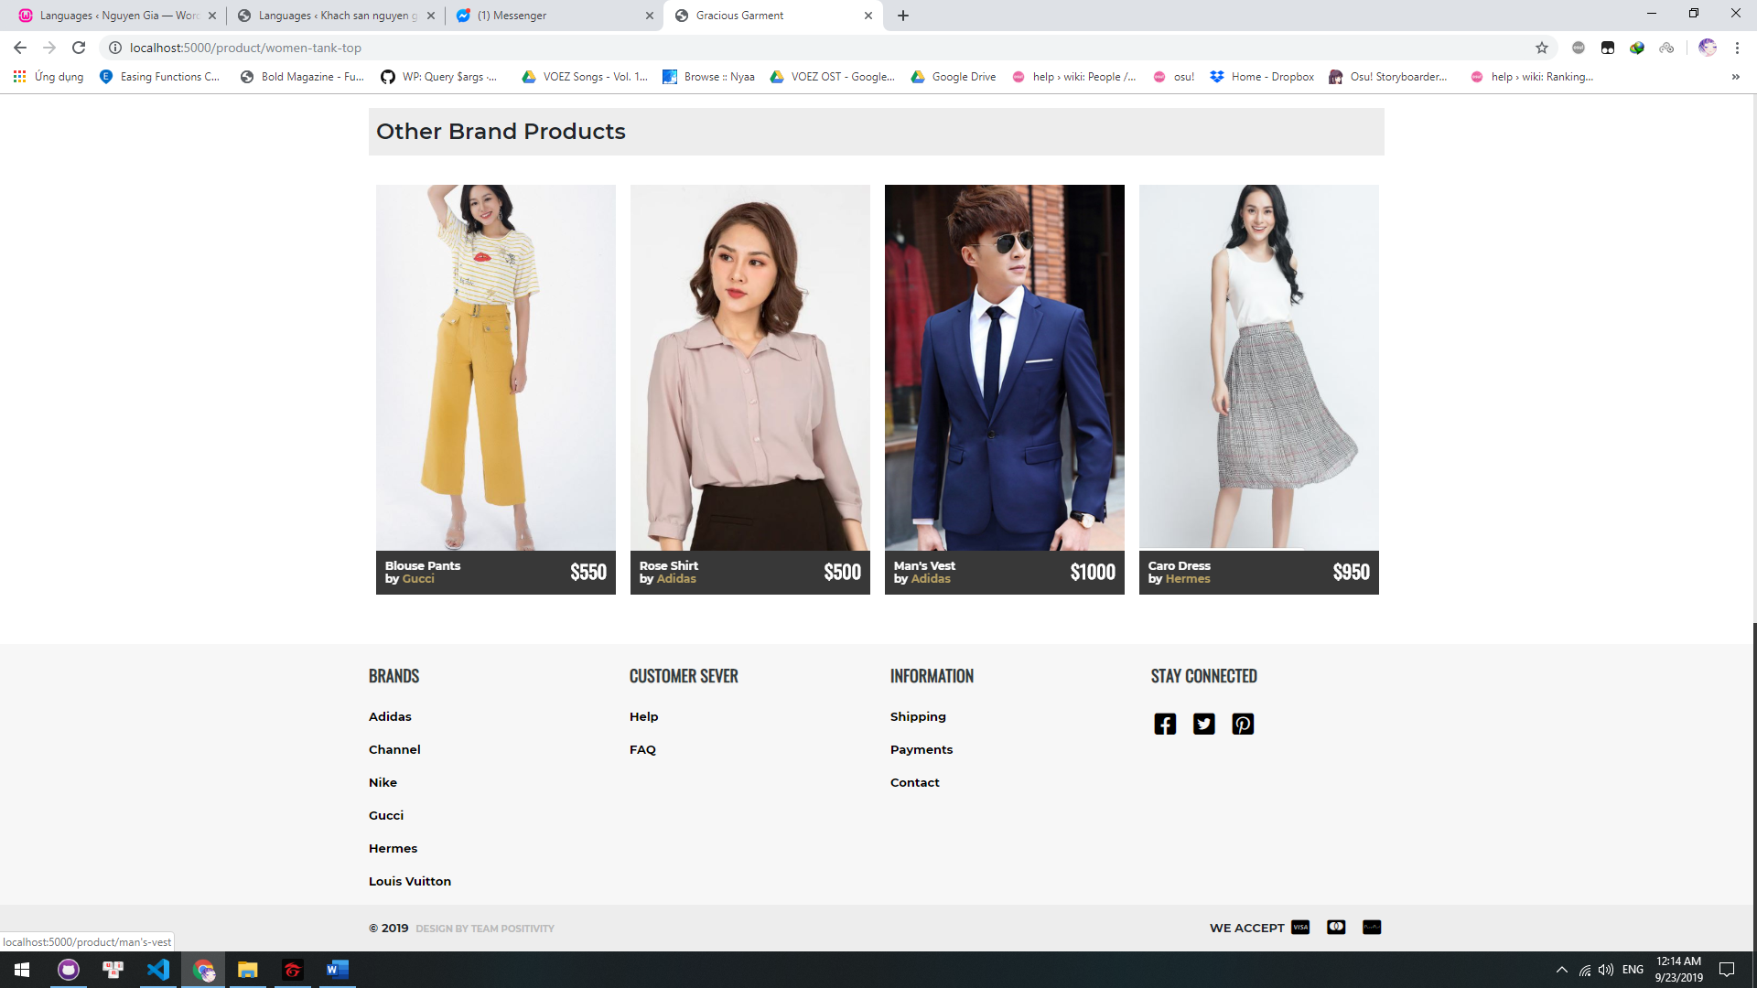

**Contact:**

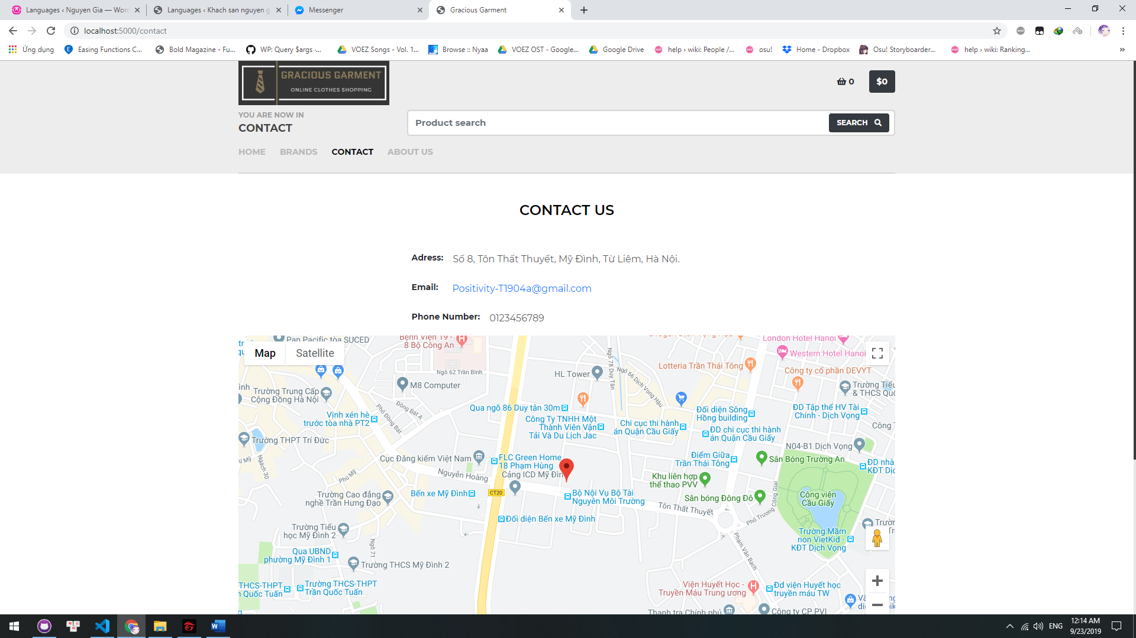

**About us:**

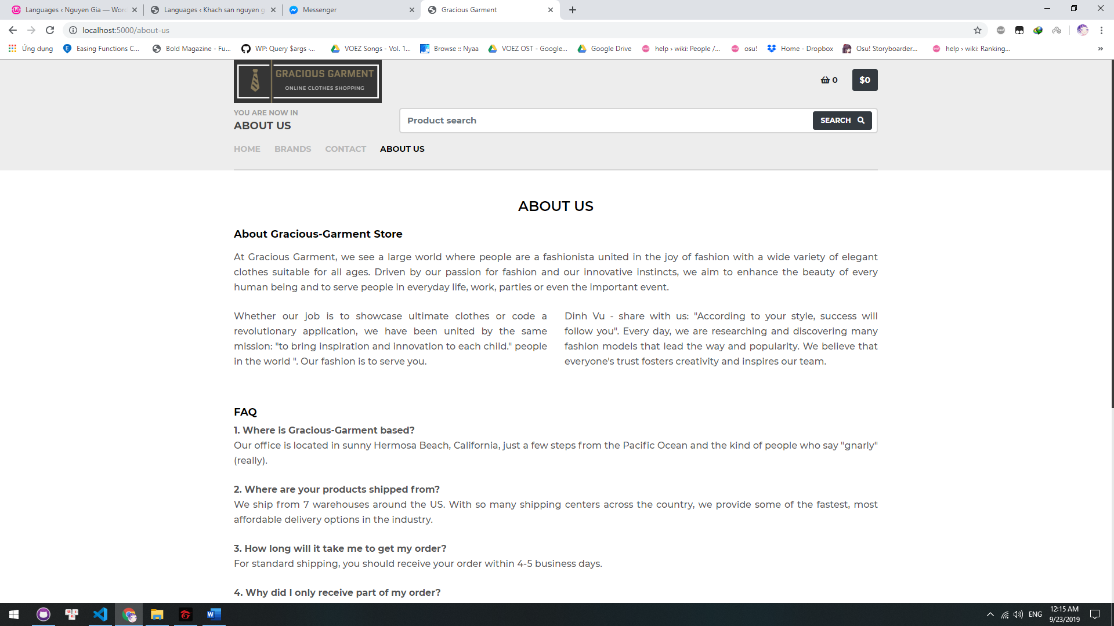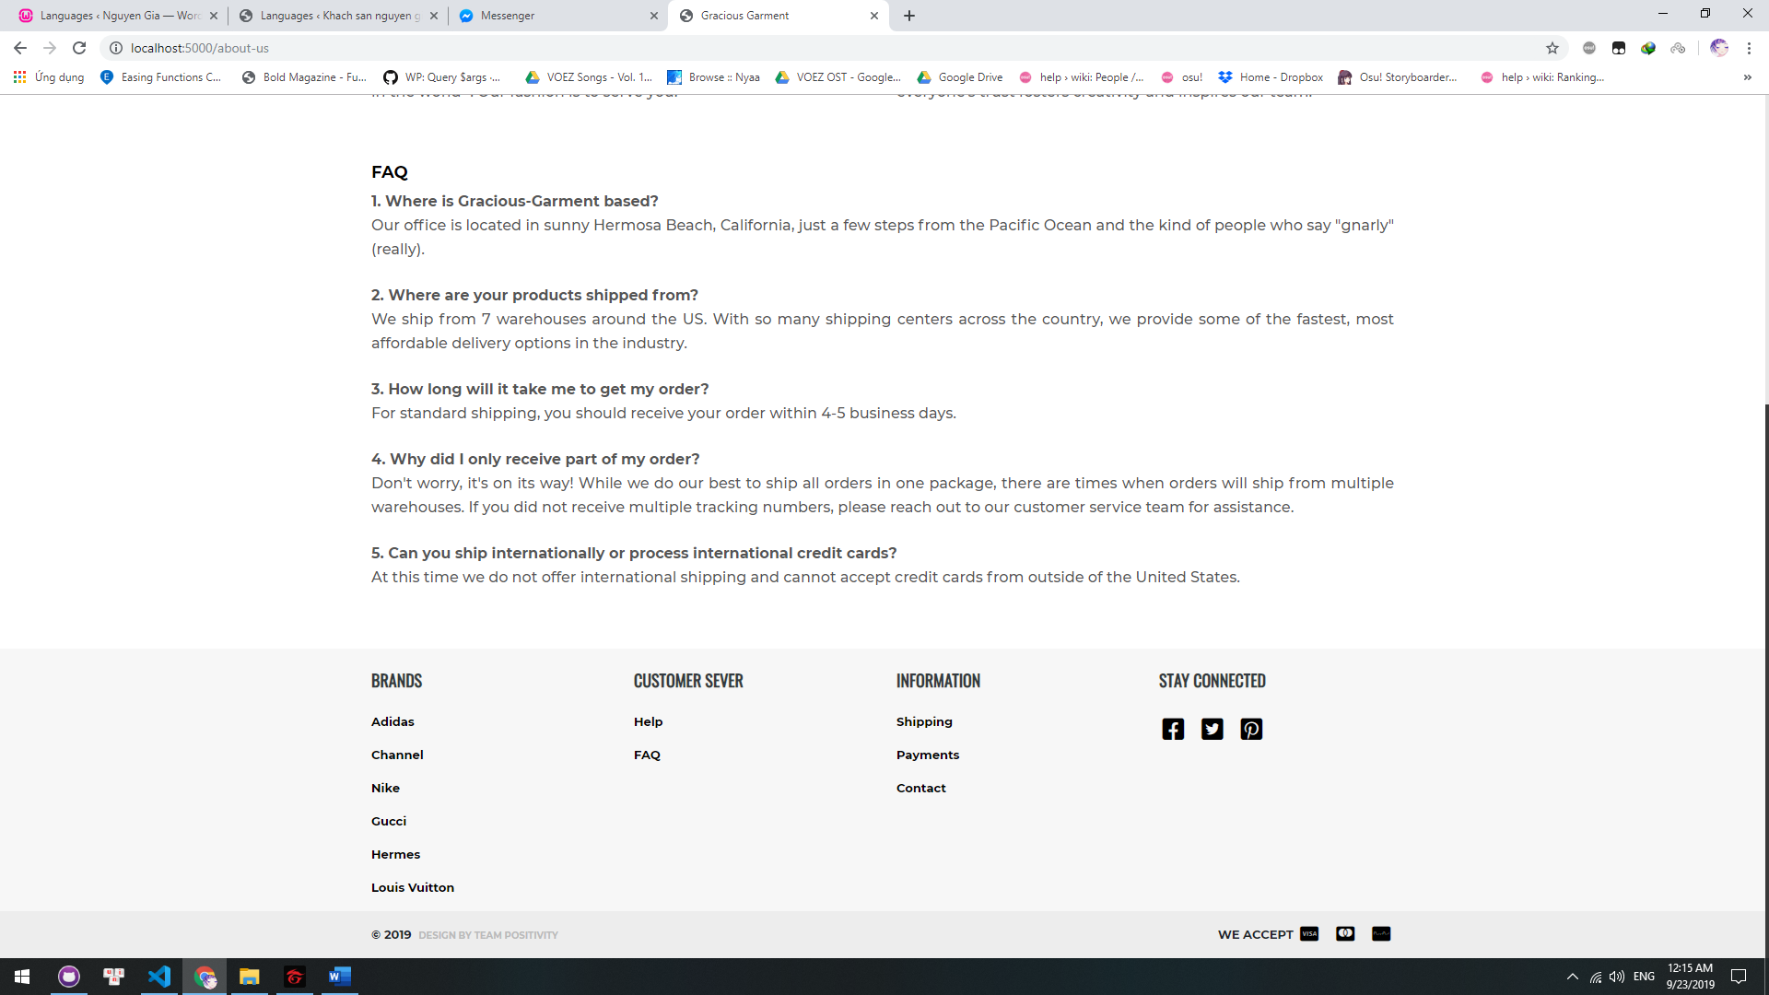

1. **Summary:**

This list below shows which tasks each individual person took part in.

|  |  |  |  |  |  |
| --- | --- | --- | --- | --- | --- |
|  | Dao Ngoc Long | Dinh Vu | Ho Ly Thai | Ngo Van Duy | Tran Hung Son |
| Home page |  |  |  | X |  |
| About us |  |  |  |  | x |
| Header |  |  | x |  |  |
| Footer |  |  | x |  |  |
| Category |  | x |  |  |  |
| Checkout-address | X |  |  |  |  |
| Checkout-payment | X |  |  |  |  |
| Checkout-summary | X |  |  |  |  |
| Checkout-cart | X |  |  |  |  |
| Checkout-confirm | X |  |  |  |  |
| Product-detail |  | x |  |  | x |
| Contact |  |  | x |  |  |
| Admin-add |  |  |  | x |  |
| Admin-edit |  |  |  | x |  |
| Admin-list |  |  |  | x |  |
| Admin-order |  |  |  | x |  |
| Frontend javascript |  | x | x |  |  |
| Backend javascript | X | x |  |  |  |
| Database input/Find information |  |  |  | x | x |
| Review and fix code |  | x |  |  |  |
| Documentation | x |  |  |  | x |
| Map |  |  | x |  |  |